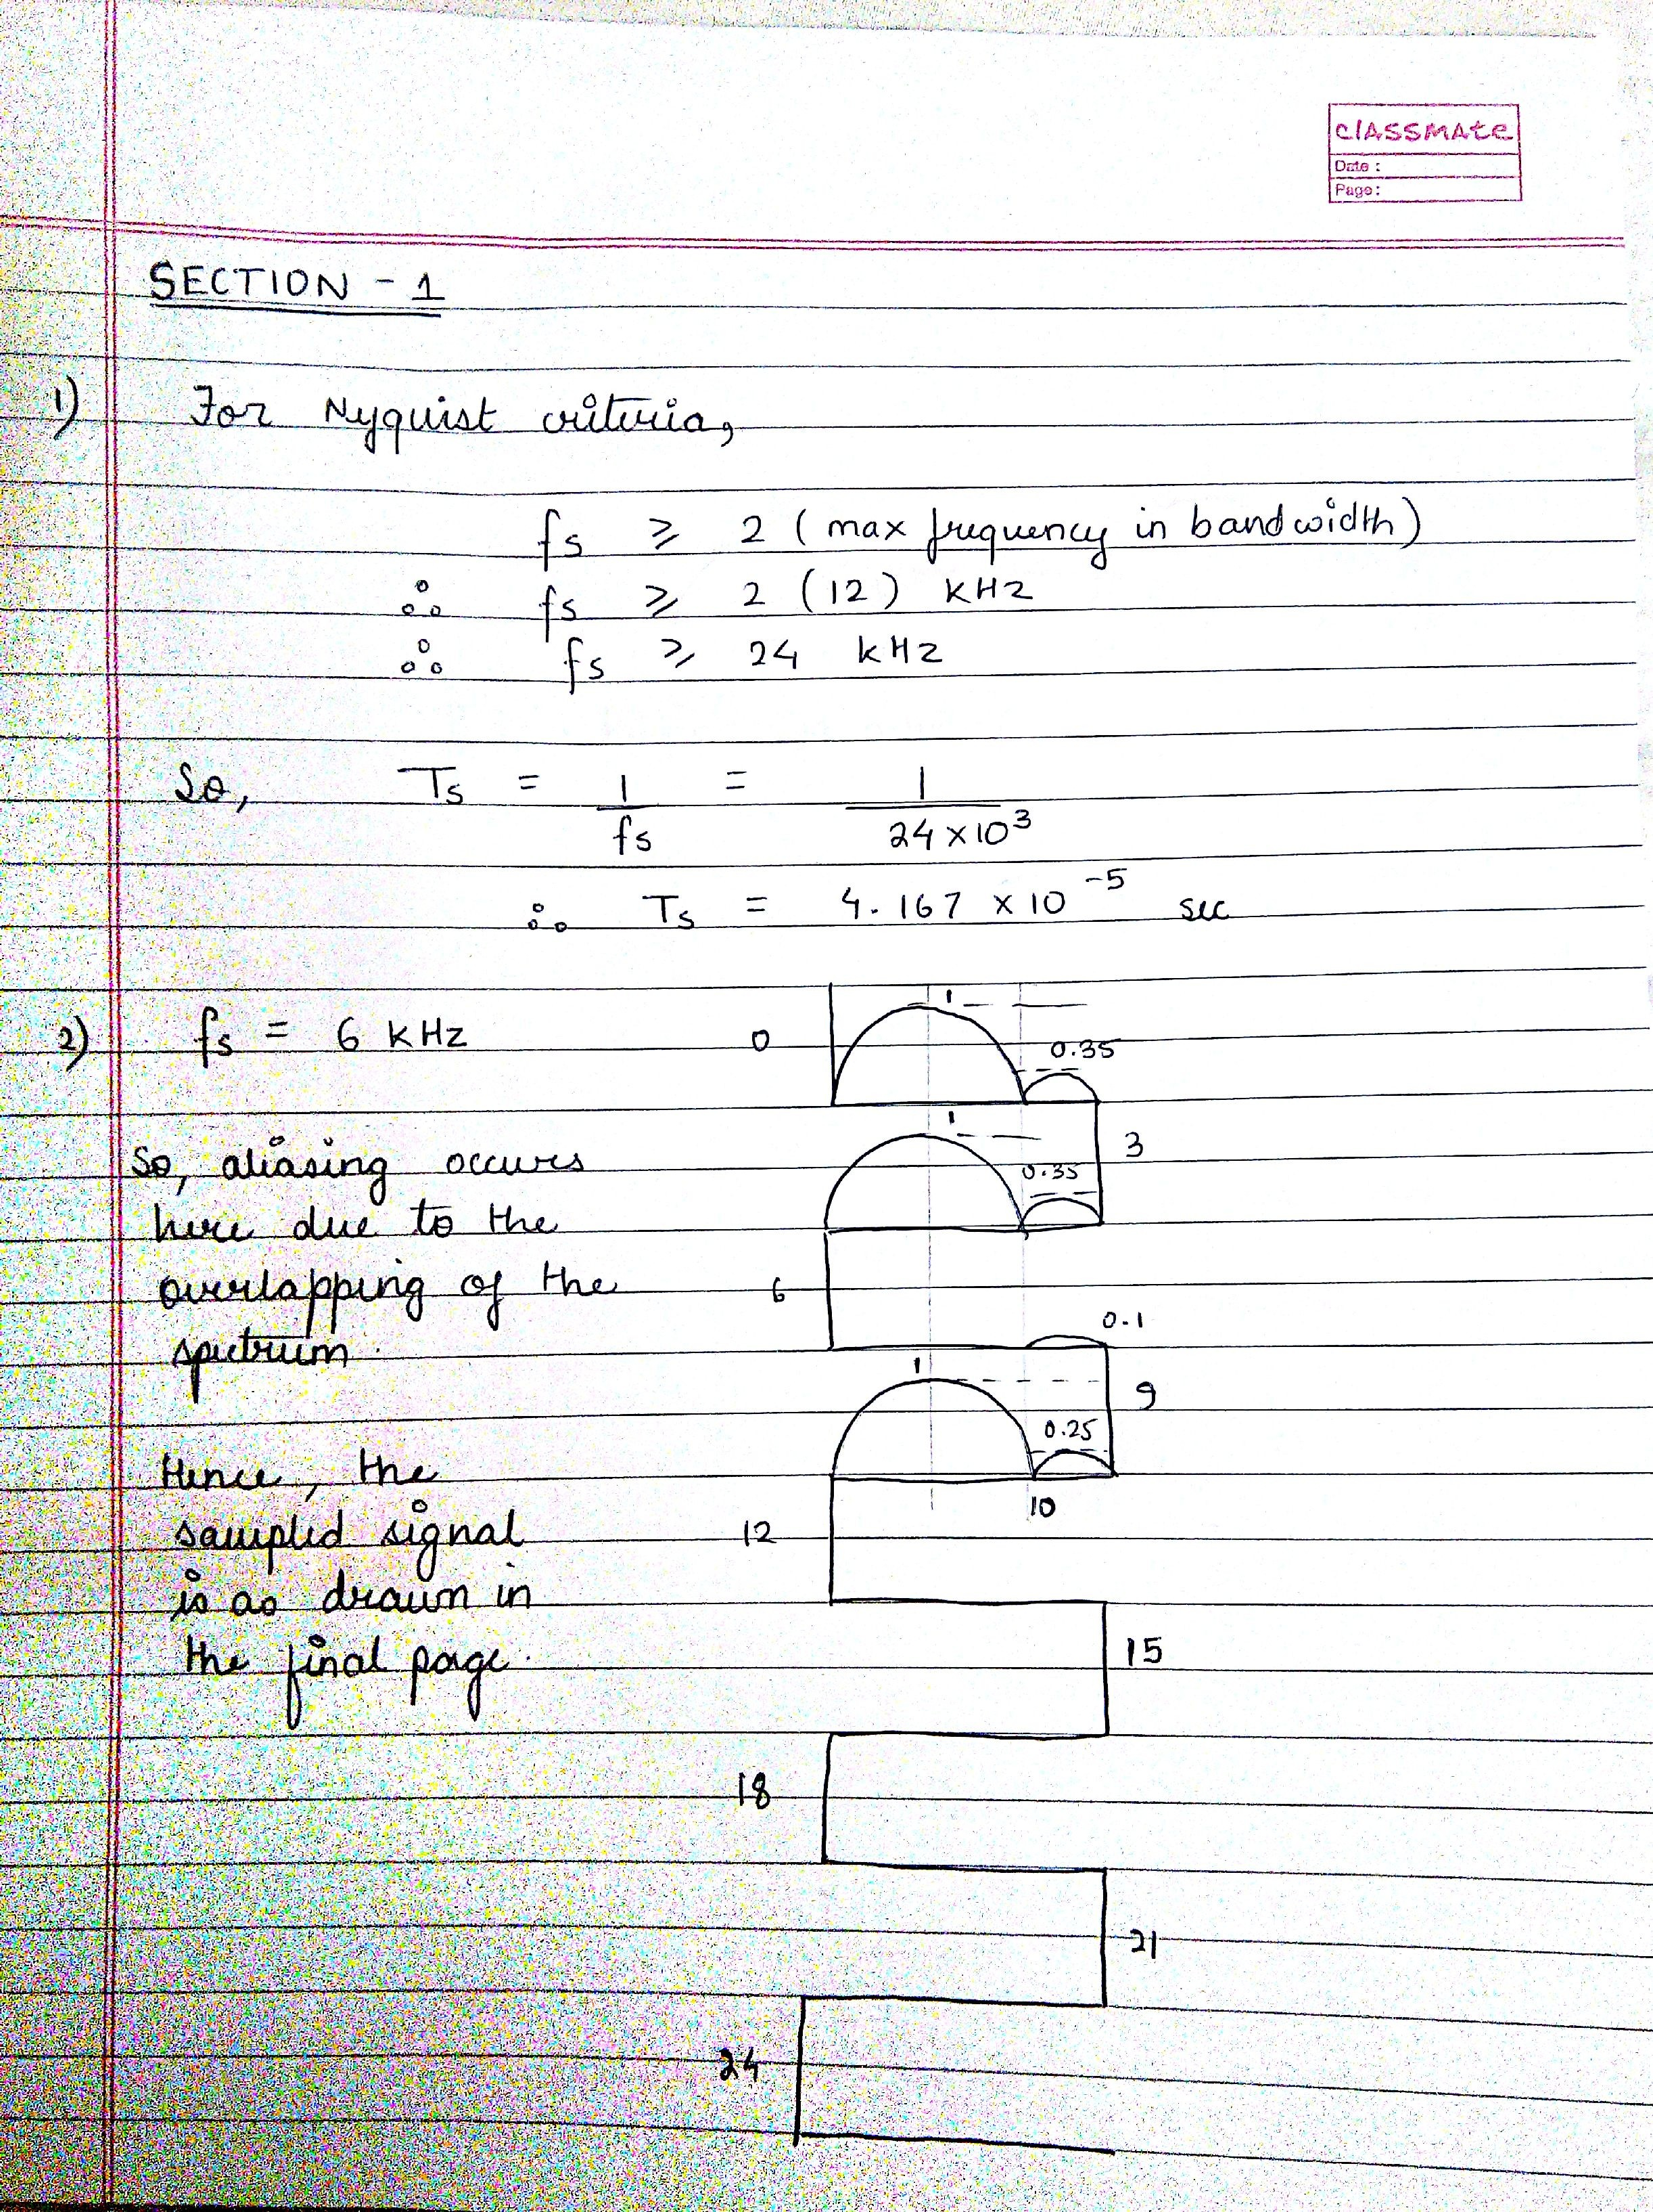

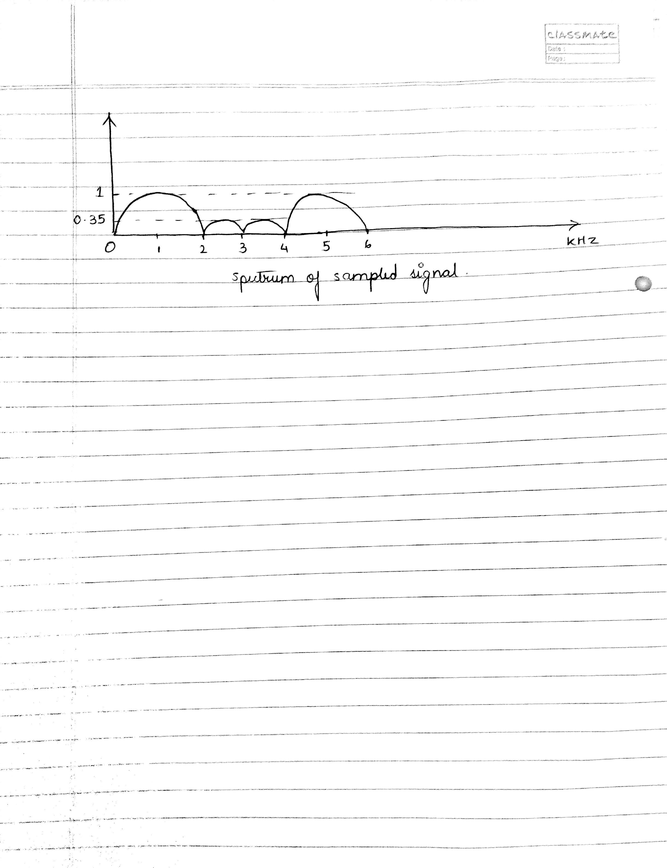

Section – 2

Question 1 and 2

% -- -- -- -- -- -- -- -- -- -- -- -- -- -- -- -- -- -- -- -- -- -- -- -- -- -- -- -- -- -- -- -- -

% TITLE: Section II - Filter Design

%

% Purpose: To design a set of Butterworth IIR filters that matches the

% specifications.

% Date created: 07/14/2016 Author: Tamoghna Chattopadhyay

% Date modified: rev1 - 07/18/2016

% -- -- -- -- -- -- -- -- -- -- -- -- -- -- -- -- -- -- -- -- -- -- -- -- -- -- -- -- -- -- -- -- -

% Filter Specifications

% Butterworth Bandpass Filter

[ nbwbp, wbwbp ] = buttord( [ 5.95/22.05 16.15/22.05 ], [ 5.15/22.5 16.95/22.5 ], -1, -30 )

% Butterworth Highpass Filter

[ nbwhp, wbwhp ] = buttord( 16.95/22.05, 16.15/22.5, -1, -30 )

% Butterworth Lowpass Filter

[ nbwlp, wbwlp ] = buttord( 5.15/22.5, 5.95/22.5, -1, -30 )

%Creating array of coefficients for Bandpass Butterworth Filter

[ bwbpnz, bwbpdz ] = butter( nbwbp, wbwbp);

%Creating array of coefficients for Highpass Butterworth Filter

[ bwhpnz, bwhpdz ] = butter( nbwhp, wbwhp, 'high');

%Creating array of coefficients for Lowpass Butterworth Filter

[ bwlpnz, bwlpdz ] = butter( nbwlp, wbwlp);

% Producing Plots of frequency response

% Bandpass Butterworth Filter

[a_bp,f1] = freqz ( bwbpnz, bwbpdz, 1024,44100);

figure(1);

plot(f,abs(a_bp),'k',...

[0 5150 5150], [0.03 0.03 0.1],'r-',...

[5950 5950 16150 16150 5950],[0.9 1 1 0.9 0.9],'r-',...

[22050 16950 16950],[0.03 0.03 0.1],'r-');

title('Band-Pass Filter - Magnitude for Butterworth Filter');

xlabel (' Frequency in Hertz ' );

ylabel (' Magnitude (unknown) ');

grid on;

figure(2);

zplane( bwbpnz, bwbpdz );

title( 'Band Pass for Butterworth Filter' );

% Highpass Butterworth Filter

[a_hp,f2] = freqz ( bwhpnz, bwhpdz, 1024,44100);

figure(3);

plot(f2,abs(a_hp),'k',...

[0 16150 16150],[0.03 0.03 0.1],'r-',...

[16950 16950 22050 22050 16950],[0.9 1 1 0.9 0.9],'r-');

title('High-Pass Filter - Magnitude for Butterworth Filter');

xlabel (' Frequency in Hertz ' );

ylabel (' Magnitude (unknown) ');

grid on;

figure(4);

zplane( bwhpnz, bwhpdz );

title( 'High Pass for Butterworth Filter' );

% Lowpass Butterworth Filter

[a_lp,f3] = freqz ( bwlpnz, bwlpdz, 1024,44100);

figure(5);

plot(f3,abs(a_lp),'k',...

[0 5150 5150 0], [1 1 0.9 0.9], 'r-',...

[22050 5950 5950], [0.03 0.03 0.1], 'r-' );

title('Low-Pass Filter - Magnitude for Butterworth Filter');

xlabel (' Frequency in Hertz ' );

ylabel (' Magnitude (unknown) ');

grid on;

figure(6);

zplane( bwlpnz, bwlpdz );

title( 'Low Pass for Butterworth Filter' );

% Generate impulse response of system.

d = zeros( 2048, 1 );

d(64) = 1.0;

llp = filter( bwlpnz, bwlpdz, d );

hlp = filter( bwhpnz, bwhpdz, d );

blp = filter( bwbpnz, bwbpdz, d );

% Produce a plot of the frequency responses overlaid on one another.

figure(7);

subplot( 311),plot( llp(1:512) );

title( 'Impulse Response of Low Pass' );

xlabel('Length of filter');

ylabel('Response of filter');

subplot( 312),plot( blp(1:256) );

title( 'Impulse Response of Band Pass' );

xlabel('Length of filter');

ylabel('Response of filter');

subplot( 313),plot( hlp(1:128) );

title( 'Impulse Response of High Pass' );

xlabel('Length of filter');

ylabel('Response of filter');

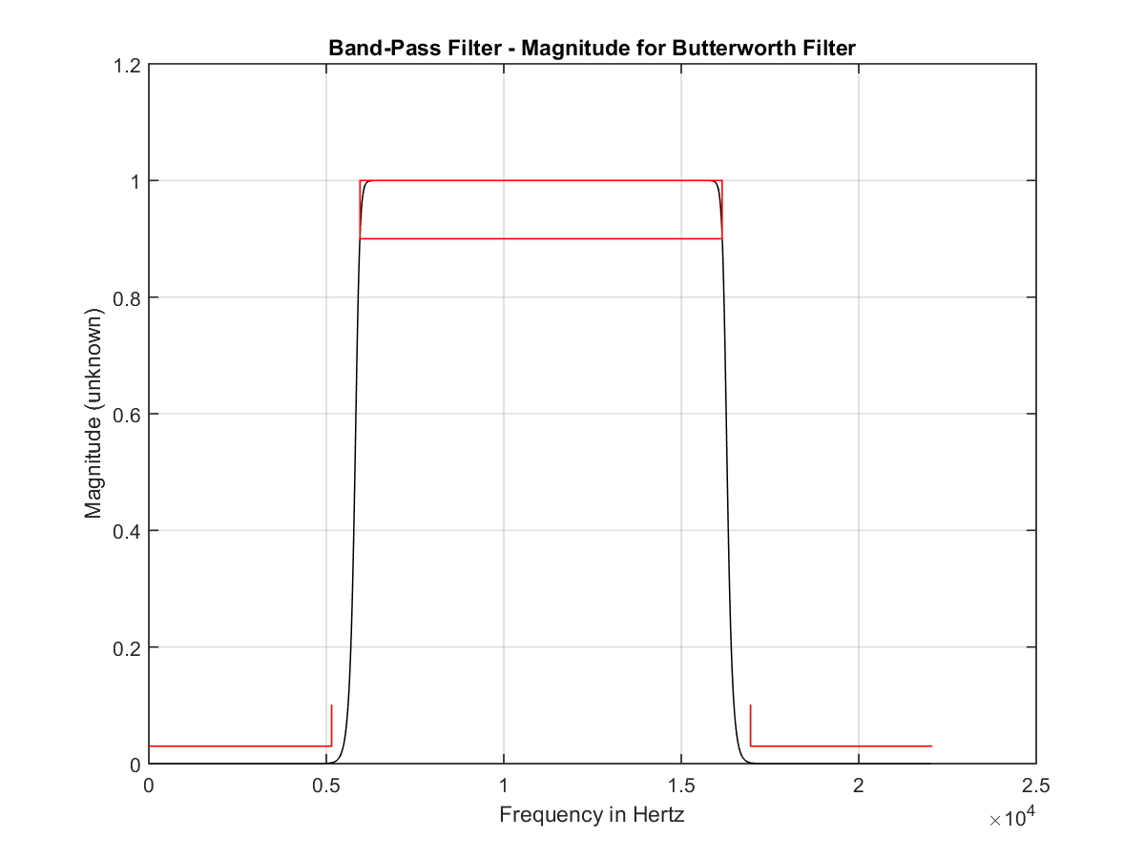

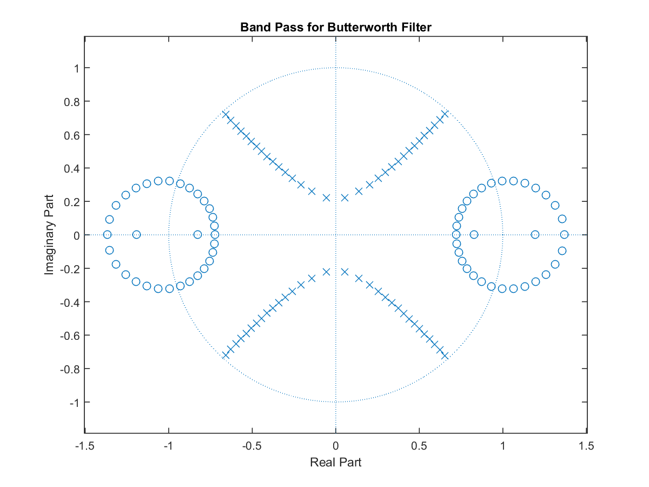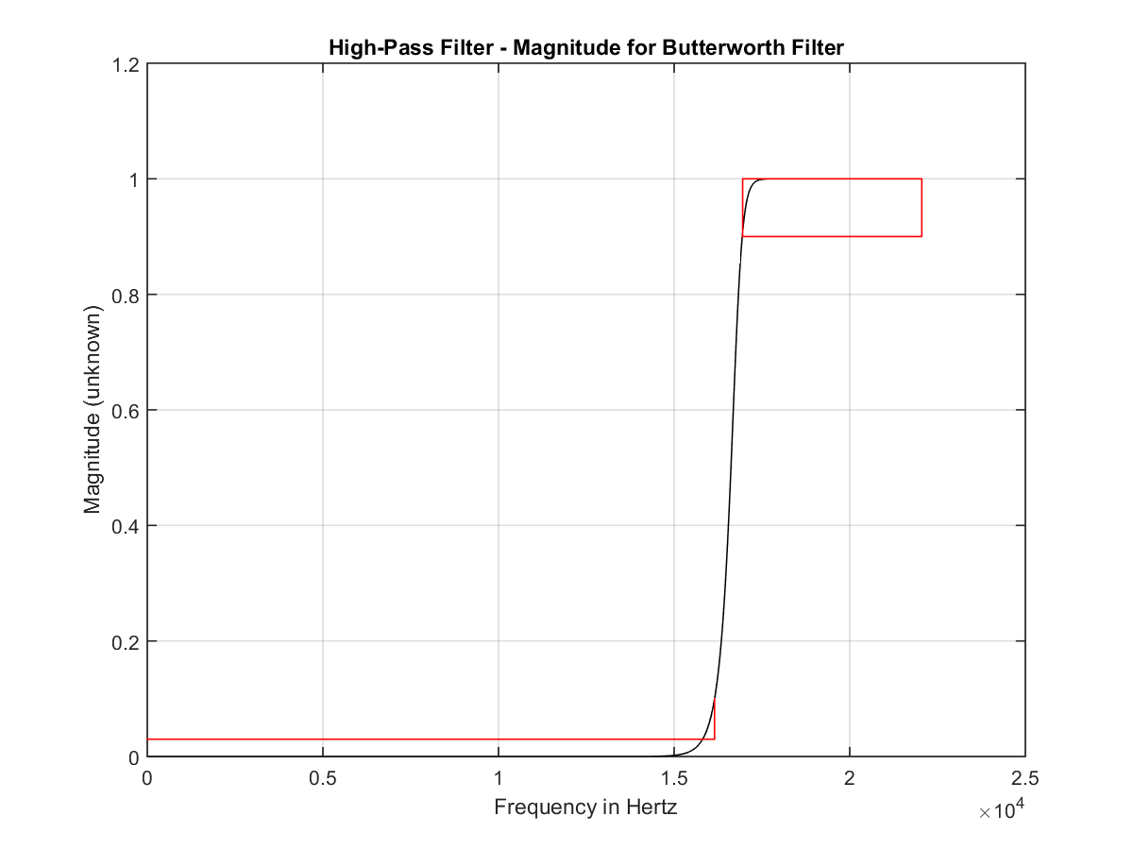

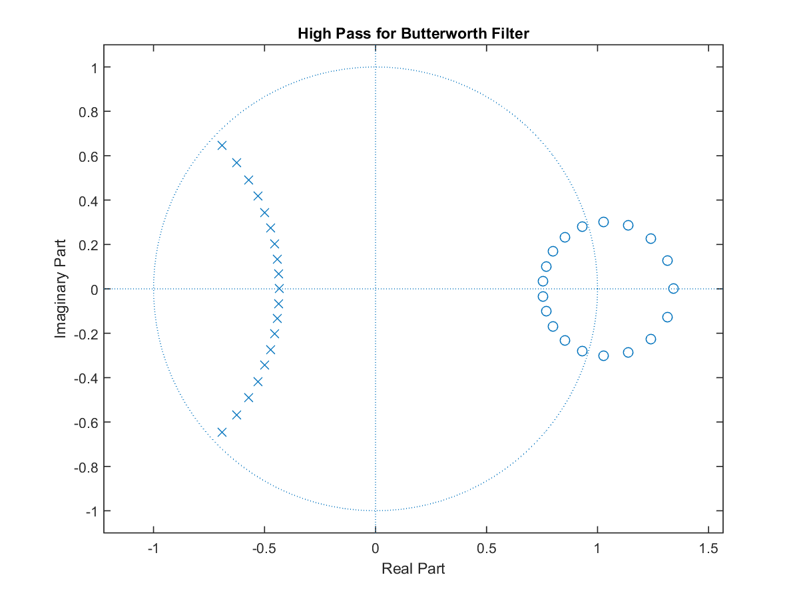

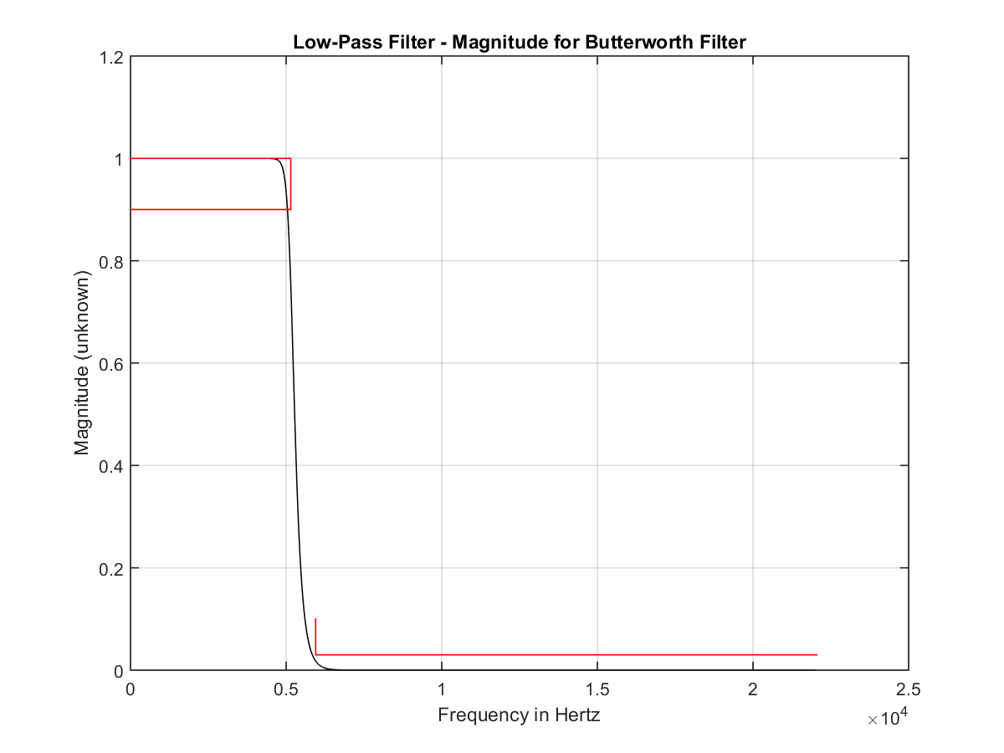

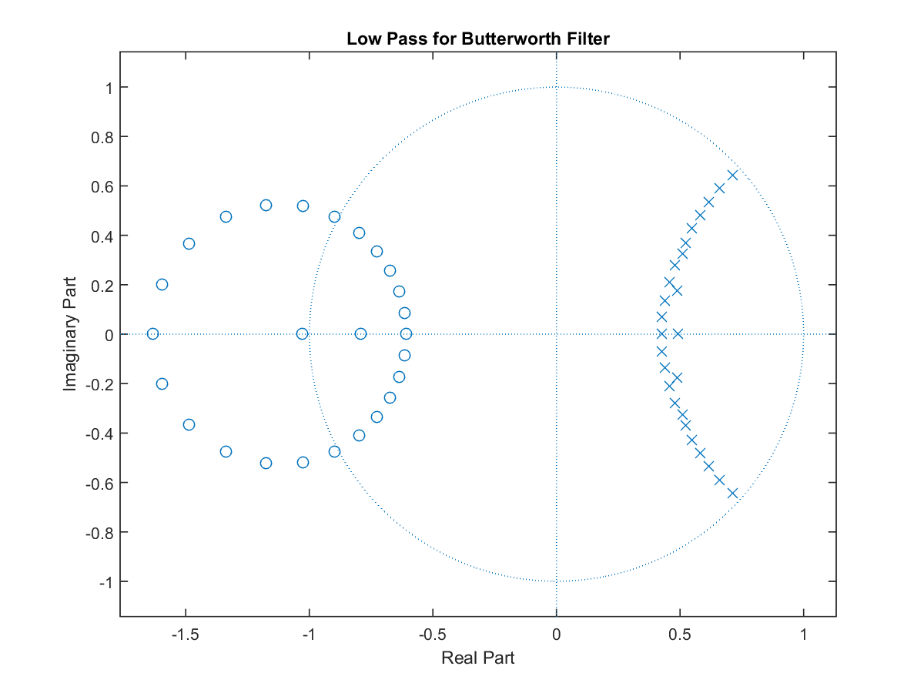

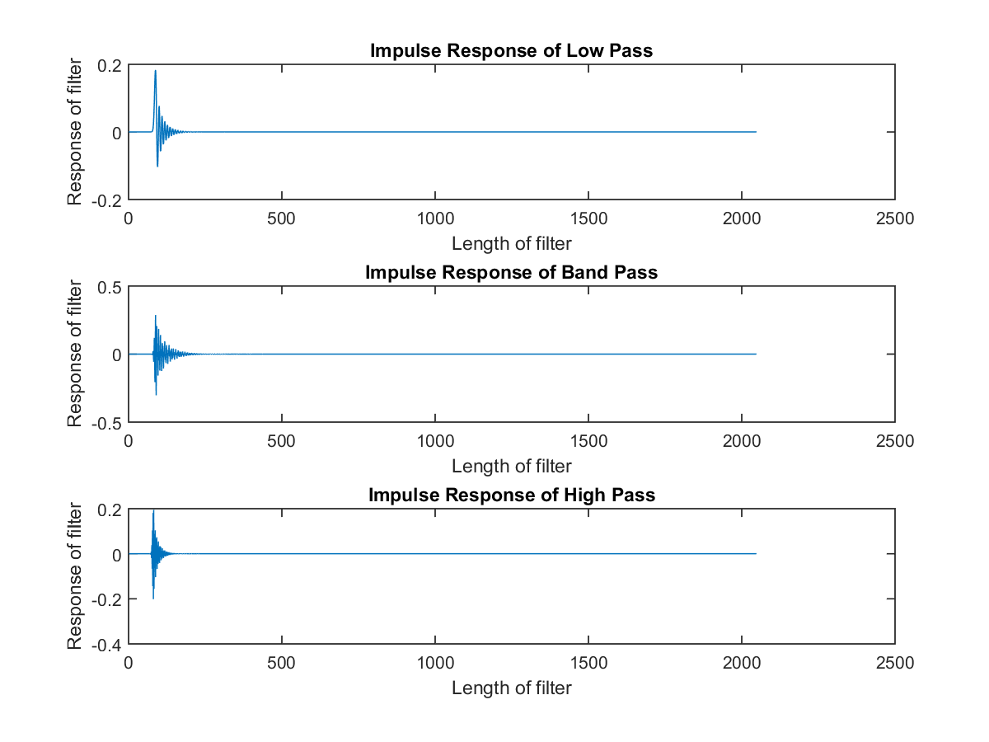

Question 3

% -- -- -- -- -- -- -- -- -- -- -- -- -- -- -- -- -- -- -- -- -- -- -- -- -- -- -- -- -- -- -- -- -

% TITLE: Section II - Filter Design

%

% Purpose: To design a set of FIR filters that matches the

% specifications.

% Date created: 07/25/2016 Author: Tamoghna Chattopadhyay

% Date modified: rev1 - 07/25/2016

% -- -- -- -- -- -- -- -- -- -- -- -- -- -- -- -- -- -- -- -- -- -- -- -- -- -- -- -- -- -- -- -- -

% Filter Specifications

% Lowpass Filter

lp = firls_hamming_search( [0 5.15/22.5 5.95/22.5 1], [ 1 1 0 0], 0.1 );

figure(1);

plot(lp);

title('Impulse Response of Low Pass');

xlabel('Length of filter');

ylabel('Response of filter');

grid on;

% Bandpass Filter

bp = firls_hamming_search( [0 5.15/22.5 5.95/22.5 16.15/22.5 16.95/22.5 1], [ 0 0 1 1 0 0], 0.1 );

figure(2);

plot(bp);

title('Impulse Response of Band Pass');

xlabel('Length of filter');

ylabel('Response of filter');

grid on;

% Highpass Filter

hp = firls_hamming_search( [0 16.15/22.5 16.95/22.5 1], [ 0 0 1 1 ], 0.1 );

figure(3);

plot(hp);

title('Impulse Response of High Pass');

xlabel('Length of filter');

ylabel('Response of filter');

grid on;

% Create Frequency Response of each filter.

w = [0:pi/256:pi];

lpfr = freqz( lp, 1, w );

bpfr = freqz( bp, 1, w );

hpfr = freqz( hp, 1, w );

% Produce a plot of the frequency responses overlaid on one another.

figure(4);

subplot( 311),plot( w, abs(lpfr) );

title( 'Frequency Response of Low Pass' );

xlabel (' Frequency in Hertz ' );

ylabel (' Magnitude (unknown) ');

subplot( 312),plot( w, abs(bpfr) );

title( 'Frequency Response of Band Pass' );

xlabel (' Frequency in Hertz ' );

ylabel (' Magnitude (unknown) ');

subplot( 313),plot( w, abs(hpfr) );

title( 'Frequency Response of High Pass' );

xlabel (' Frequency in Hertz ' );

ylabel (' Magnitude (unknown) ');

% Plot the pole zero plot

figure(5);

zplane( lp, 1 );

title ('Pole Zero Plot - Low Pass Filter');

figure(6);

zplane( bp, 1 );

title ('Pole Zero Plot - Band Pass Filter');

figure(7);

zplane( hp, 1 );

title ('Pole Zero Plot - High Pass Filter');

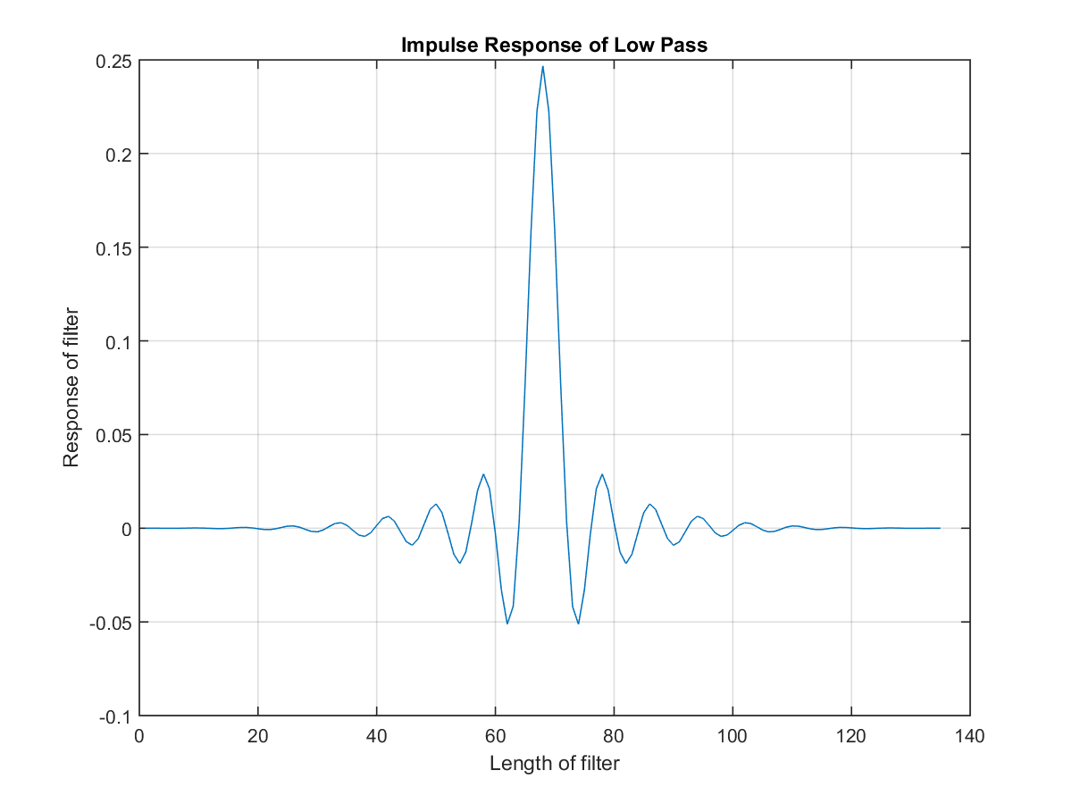

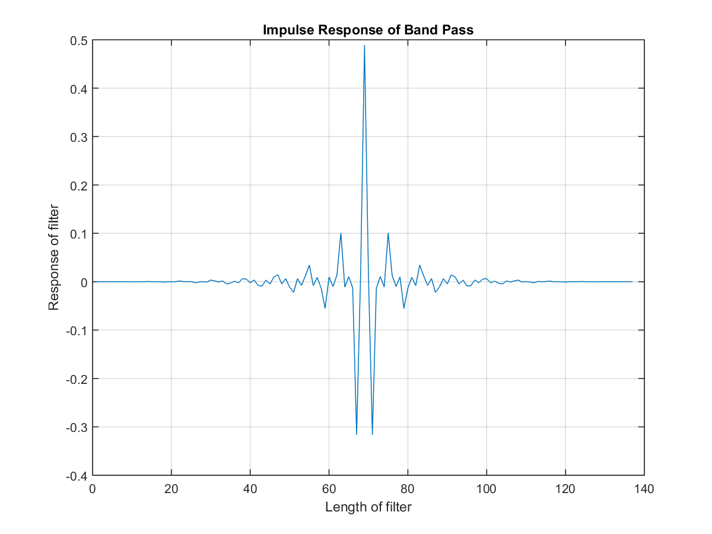

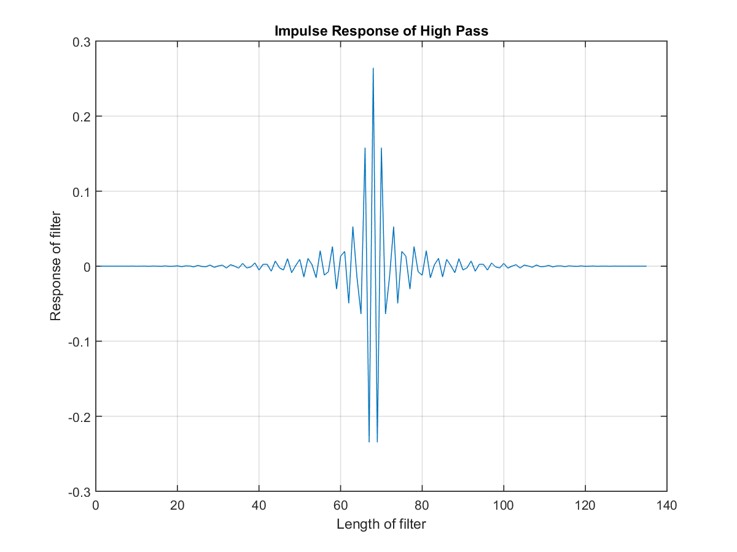

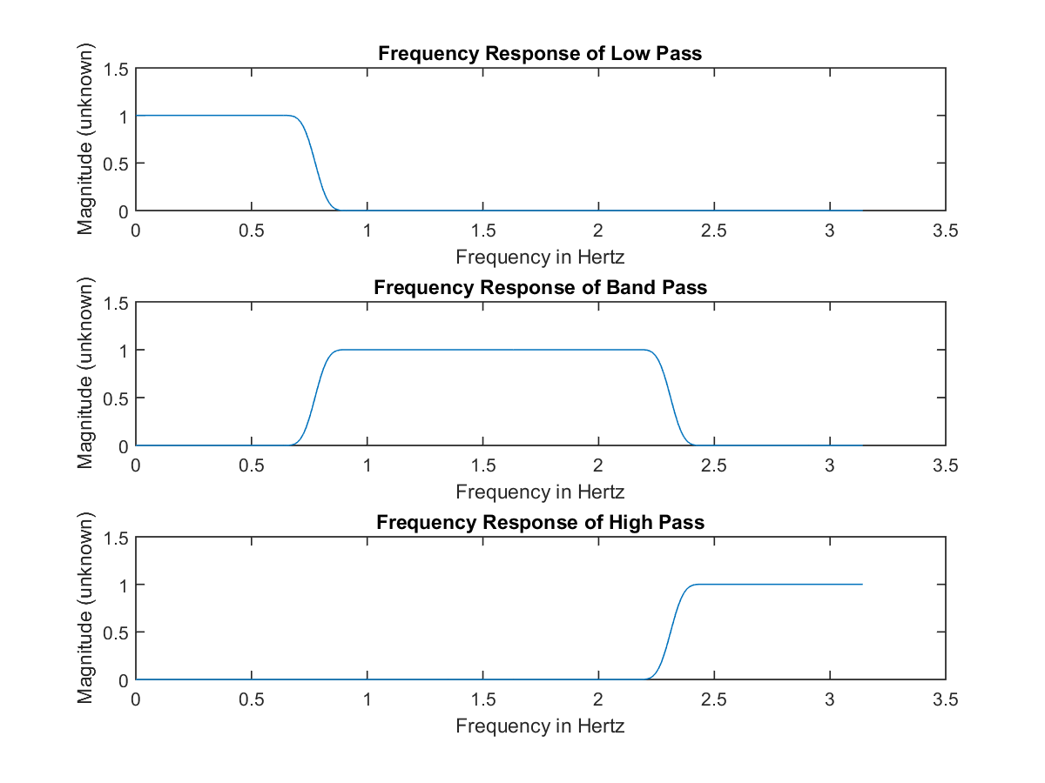

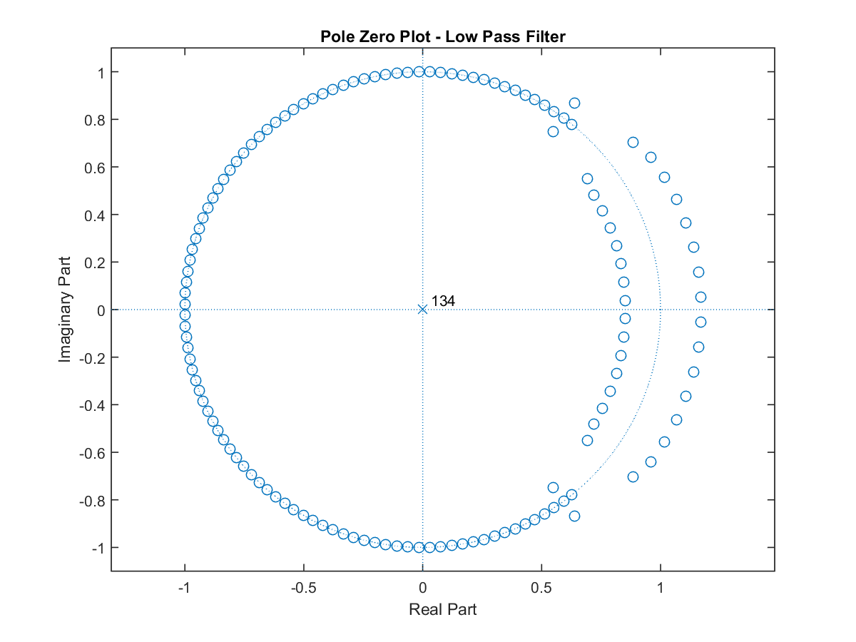

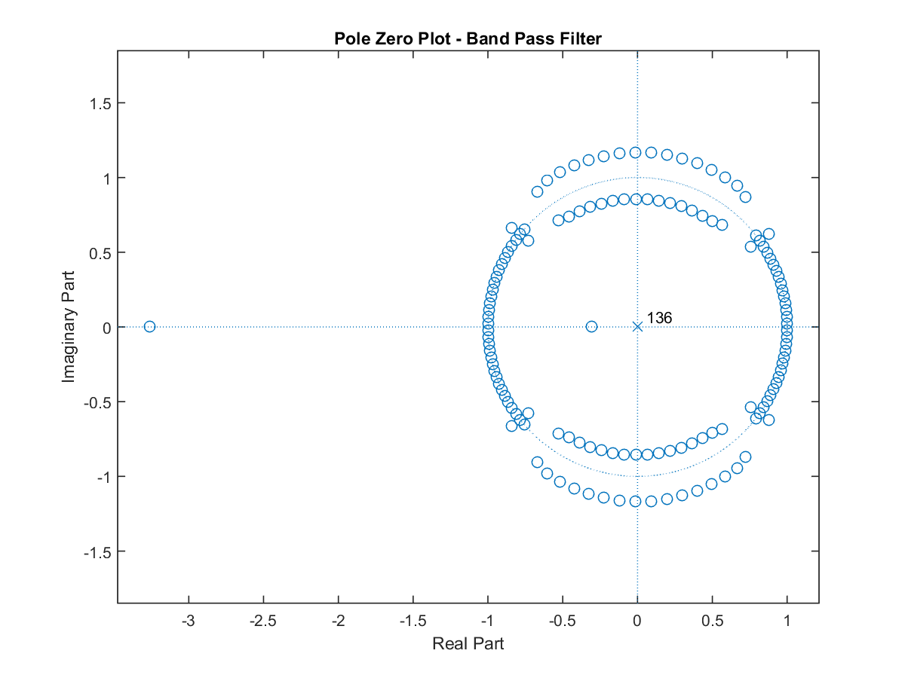

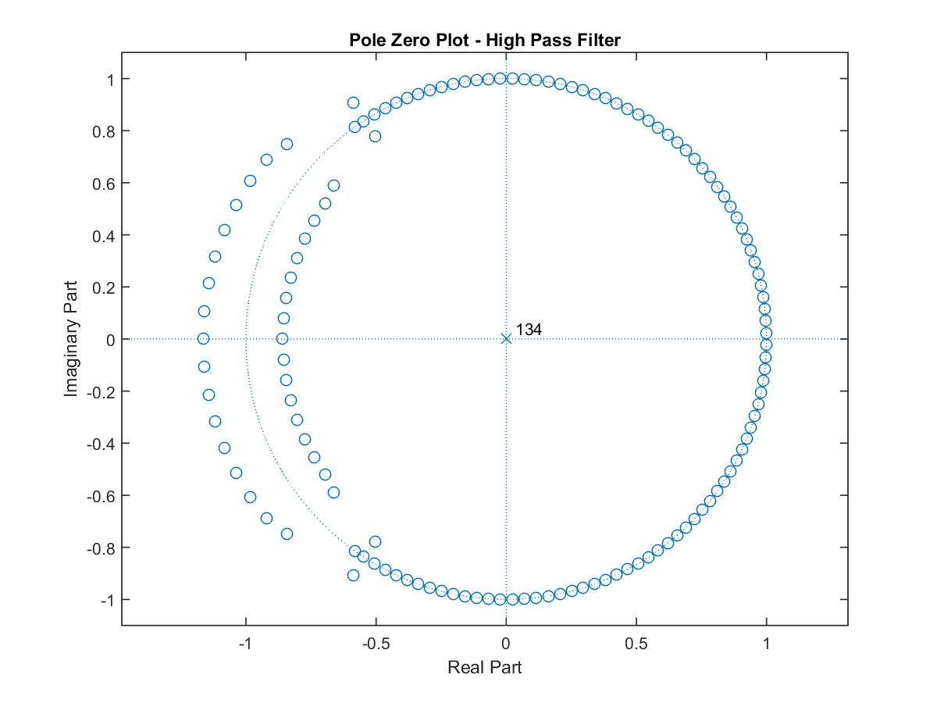

QUESTION 4

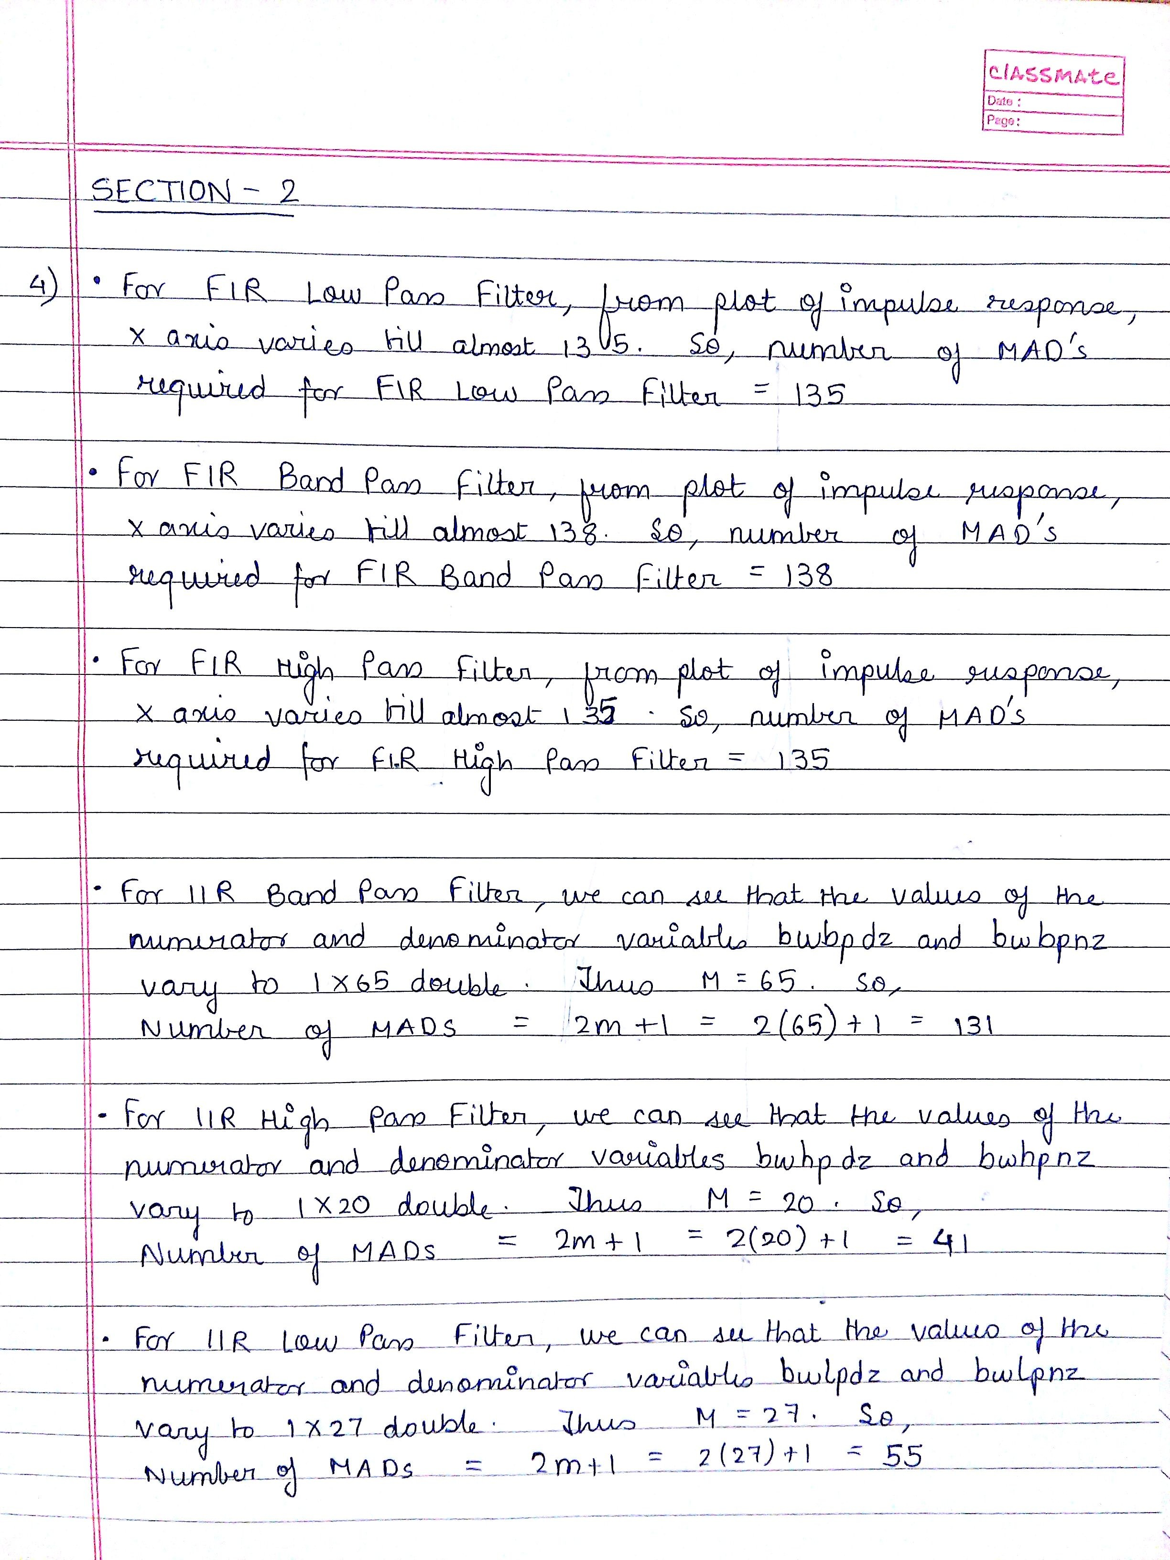

SECTION – 3

QUESTION 1

% -- -- -- -- -- -- -- -- -- -- -- -- -- -- -- -- -- -- -- -- -- -- -- -- -- -- -- -- -- -- -- -- -

% TITLE: Section III - Decimation and Frequency shifting.

%

% Purpose: To plot a signal in the file fexam.mat and it's spectrum

%

% Date created: 07/25/2016 Author: Tamoghna Chattopadhyay

% Date modified: rev1 - 07/25/2016

% -- -- -- -- -- -- -- -- -- -- -- -- -- -- -- -- -- -- -- -- -- -- -- -- -- -- -- -- -- -- -- -- -

load('fexam.mat');

sound(sig,44100);

SIG = fft(sig); % Computes the Fourier Transform of sig

figure(1);

plot( abs( SIG ) ); % Plot the spectrum

title('Spectrum of signal in fexam.mat');

xlabel (' Frequency in Hertz ' );

ylabel (' Magnitude (unknown) ');

N=length(SIG);

figure(2);

plot(([0:N/2 - 1]/N)*44.1e3,abs(SIG(1:N/2)));

title('Spectrum of half the bandwidth for signal in fexam.mat');

xlabel (' Frequency in Hertz ' );

ylabel (' Magnitude (unknown) ');

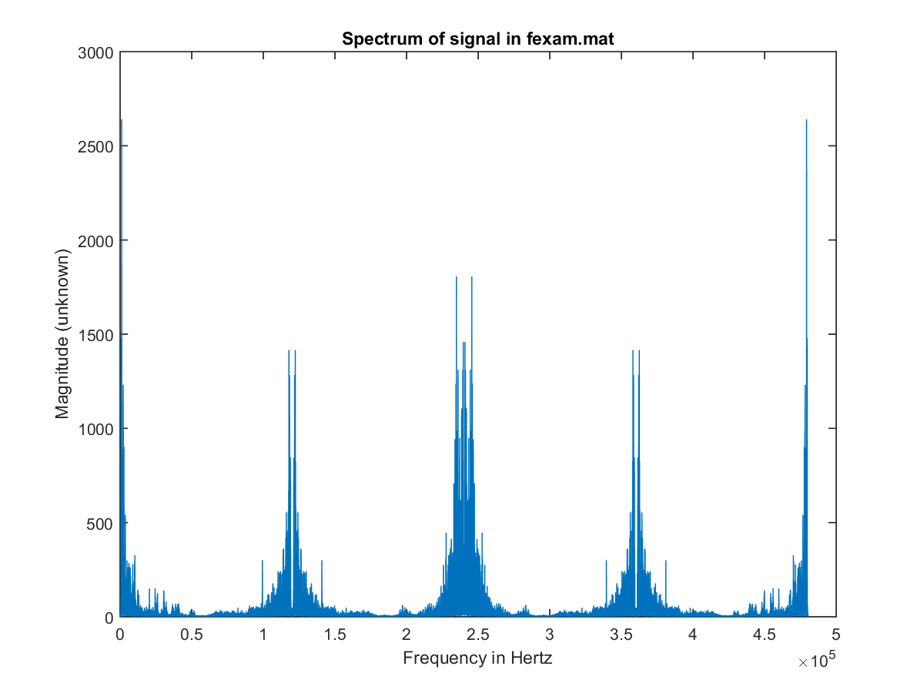

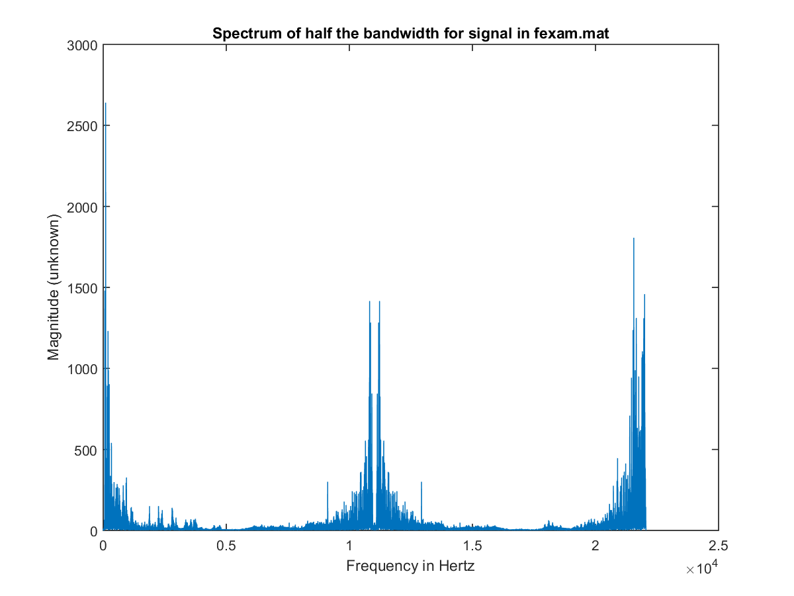

QUESTION 2, 3 AND 4

% -- -- -- -- -- -- -- -- -- -- -- -- -- -- -- -- -- -- -- -- -- -- -- -- -- -- -- -- -- -- -- -- -

% TITLE: Section III - Decimation and Frequency shifting.

%

% Purpose: Apply IIR Filters from Section II to signal in fexam.mat

%

% Date created: 07/25/2016 Author: Tamoghna Chattopadhyay

% Date modified: rev1 - 07/25/2016

% -- -- -- -- -- -- -- -- -- -- -- -- -- -- -- -- -- -- -- -- -- -- -- -- -- -- -- -- -- -- -- -- -

% Filter Specifications

% Butterworth Bandpass Filter

[ nbwbp, wbwbp ] = buttord( [ 5.95/22.05 16.15/22.05 ], [ 5.15/22.5 16.95/22.5 ], -1, -30 )

% Butterworth Highpass Filter

[ nbwhp, wbwhp ] = buttord( 16.95/22.05, 16.15/22.5, -1, -30 )

% Butterworth Lowpass Filter

[ nbwlp, wbwlp ] = buttord( 5.15/22.5, 5.95/22.5, -1, -30 )

%Creating array of coefficients for Bandpass Butterworth Filter

[ bwbpnz, bwbpdz ] = butter( nbwbp, wbwbp);

%Creating array of coefficients for Highpass Butterworth Filter

[ bwhpnz, bwhpdz ] = butter( nbwhp, wbwhp, 'high');

%Creating array of coefficients for Lowpass Butterworth Filter

[ bwlpnz, bwlpdz ] = butter( nbwlp, wbwlp);

%Load the signal in fexam.mat

load('fexam.mat');

sound(sig,44100);

pause;

SIG = fft(sig); % Computes the Fourier Transform of sig

% Filter the signal using Butterworth Highpass Hilter

b_hp = filter ( bwhpnz, bwhpdz, sig);

figure(1);

plot(b_hp);

title('High-Pass Filter - Magnitude for Butterworth Filter');

xlabel (' Frequency in Hertz ' );

ylabel (' Magnitude (unknown) ');

grid on;

% Filter the signal using Butterworth Lowpass Hilter

b_lp = filter ( bwlpnz, bwlpdz, sig);

figure(2);

plot(b_lp);

title('Low-Pass Filter - Magnitude for Butterworth Filter');

xlabel (' Frequency in Hertz ' );

ylabel (' Magnitude (unknown) ');

grid on;

% Filter the signal using Butterworth Bandpass Hilter

b_bp = filter ( bwbpnz, bwbpdz, sig);

figure(3);

plot(b_bp);

title('Band-Pass Filter - Magnitude for Butterworth Filter');

xlabel (' Frequency in Hertz ' );

ylabel (' Magnitude (unknown) ');

grid on;

%Decimate signals to one-fourth sampling rates

Dec_b_hp=b_hp(1:4:end);

Dec_b_lp=b_lp(1:4:end);

Dec_b_bp=b_bp(1:4:end);

%Plot the output signal after decimation

%High Pass Filter output

figure(4);

plot(Dec_b_hp);

title('High-Pass Filter - Magnitude for Butterworth Filter for Decimated Signal');

xlabel (' Frequency in Hertz ' );

ylabel (' Magnitude (unknown) ');

grid on;

%Low Pass Filter output

figure(5);

plot(Dec_b_lp);

title('Low-Pass Filter - Magnitude for Butterworth Filter for Decimated Signal');

xlabel (' Frequency in Hertz ' );

ylabel (' Magnitude (unknown) ');

grid on;

%Band Pass Filter output

figure(6);

plot(Dec_b_bp);

title('Band-Pass Filter - Magnitude for Butterworth Filter for Decimated Signal');

xlabel (' Frequency in Hertz ' );

ylabel (' Magnitude (unknown) ');

grid on;

%Fourier Transforms of filtered signals

B_HP = fft(Dec_b_hp);

B_LP = fft(Dec_b_lp);

B_BP = fft(Dec_b_bp);

%Plot the Spectrum

figure(7);

subplot( 311),plot( abs( B_HP ) );

title('Spectrum of the signal passed through High Pass Filter');

xlabel (' Frequency in Hertz ' );

ylabel (' Magnitude (unknown) ');

subplot( 312),plot( abs( B_LP ) );

title('Spectrum of the signal passed through Low Pass Filter');

xlabel (' Frequency in Hertz ' );

ylabel (' Magnitude (unknown) ');

subplot( 313),plot( abs( B_BP ) );

title('Spectrum of the signal passed through Band Pass Filter');

xlabel (' Frequency in Hertz ' );

ylabel (' Magnitude (unknown) ');

%Play the signals as sound

sound(Dec_b_hp,11.025e3);

pause;

sound(Dec_b_lp,11.025e3);

pause;

sound(Dec_b_bp,11.025e3);

pause;

